IoT Christmas Tree: Redefining the Party Landscape

Dominic Savarino
Department of Mechanical & Aerospace Engineering
The George Washington University
Washington, DC, USA
dsavarino@gwu.edu

Abstract – This project presents the development of an IoT-enabled Christmas tree system featuring dynamic lighting and motion responsive to sensor data and user control. A Raspberry Pi manages a WS2811 RGB LED strip, BH1750 ambient light sensor, motion sensors, and servo-driven animatronic eyes with custom 3D-printed housing. Python libraries including rpi_ws281x and Flask were used for real-time LED control and web-based operation. A six-layer IoT model guided the system architecture, combining perception, data processing, actuation, networking, and user interfacing. 3D spatial mapping of the LEDs enabled complex, geometry-based animations, while real-time ambient brightness was visualized through a web dashboard. Although real-time music synchronization was not achieved, time stamped animations demonstrated preliminary audio-reactive effects. The system successfully achieved responsive ambient lighting control, modular design, and low-latency remote operation. Future work will focus on improving autonomous sensor behaviors and developing real-time music synchronization techniques.
Keywords – internet-of-things, mechatronics, audio/visual engineering, sensor integration
1 Introduction
This project presents the design, development, and implementation of an Internet of Things (IoT)-enabled Christmas tree system that integrates programmable RGB LEDs, sensor-based real-time feedback, and remote web-based user control. The goal of the project was to enhance the traditional experience of holiday lighting by introducing interactive behaviors that respond to environmental factors such as ambient light and motion, while also offering manual user control through a modular and accessible interface. The system was built through a combination of hardware and software development. On the hardware side, a Raspberry Pi served as the central controller, interfacing with a WS2811 LED strip, BH1750 ambient light sensor, motion sensors, and custom 3D-printed actuators designed to animate “eyes” embedded within the tree using servo motors. On the software side, Python-based libraries, including rpi_ws281x for LED control and Flask for web hosting, were utilized to create a responsive platform capable of real-time data collection, pattern generation, and remote actuation. Careful attention was given to light handling, geometric animations generated using 3D coordinates, and real-time visualization of sensor data.

Nathan Janssen
Department of Mechanical & Aerospace Engineering
The George Washington University
Washington, DC, USA
njanssen@gwu.edu

The development process was grounded in extensive preliminary research on IoT frameworks, sensor technologies,
LED control techniques, and frequency-based signal processing for potential music synchronization. The project was executed iteratively, with multiple trails aimed at optimizing sensor feedback, LED visual effects, actuator control, and user interface design. While certain advanced features such as fully autonomous real-time music synchronization remained outside the final scope due to latency and signal processing challenges, a strong foundation was established for future improvements. Overall, this work demonstrates the feasibility of deploying compact, sensor-driven, network-connected systems for enhancing user interaction in entertainment contexts, with broad implications for future applications in home automation and IoT-based interactive displays.
2 Background and Literature Review
This project aims to create an IoT-controlled Christmas tree to manage programmable RGB LEDs, displaying dynamic geometric patterns that ideally synchronize with music and respond to ambient light and manual user inputs. Traditional Christmas tree lighting is often limited to simple color changes, lacking adaptability to real-time factors. By integrating sensors and real-time processing, this project enhances the lighting experience with interactivity, allowing the system to adjust brightness based on ambient light levels and synchronize animations with sound. This project explores how IoT and interactive displays can elevate user interaction and energy efficiency in smart lighting systems, with potential applications extending beyond seasonal decor to broader home automation and entertainment. Development involves hardware integration of the Raspberry Pi, sensors, a 50 LED strip, 3D printed parts, actuators, along with Python-based code for signal processing, light pattern generation, and web-based user interfaces. Multiple trials will be conducted to optimize sensor feedback, LED behavior, and overall user experience.
Before launching the project and ordering the necessary materials, extensive research was done to explore the relevant focus areas regarding the scope of the final product. Background research included a review of new Python libraries, sensor specifications, frequency analysis guides, IoT models, and assembly considerations. To understand Raspberry Pi LED handling, the Adafruit CircuitPython NeoPixel library was chosen as a first reference. This library contains several resources for using LED strips on platforms such as the Raspberry Pi and other computers or microcontrollers. It details installation, GPIO setup, and configuring RGB color modes. The library also allows color assignment with tuples of hex values, supports batch updates, and provides methods for adjusting brightness and controlling color order. It emphasizes efficient LED handling through a Python sequence-like interface, allowing for complex patterns and real-time performance [1]. The paper “Research and Implementation of RGB-LED Mixed Light Matching along with Music Playing” explores the relationship between music and color through synesthesia, where audio signals are analyzed in real-time to generate matching LED colors. The system uses fast Fourier transforms to convert audio signals to frequency domains, compares the resulting spectrum with predefined musical chords, and assigns a corresponding color based on a spectrum-color mapping model. Wavelet transforms are used to reduce noise and improve accuracy, creating dynamic, synchronized lighting effects that respond to musical input. The use of pulse width modulation (PWM) can alternatively be used to drive RGB-LEDs for precise control over color output [2].
3 Methods and Implementation
To encapsulate a formal IoT product, a 6-layer model is proposed. The model consists of the perception, data processing, actuation, network, application, and business layers. The perception layer is closest to the data and consists of the motion and brightness sensors that observe the physical world. The data processing layer is where the sensor data is interpreted by the Raspberry Pi, and the data can be read, stored, or used for other processes. The actuation layer consists of the combination of both user and sensor inputs. The LEDs and servo motors are both able to have user controls, being able to change both the lighting pattern of the LEDs and the movement of the servo motors. In addition, both components have aspects that are controlled by the sensors. The network layer is brought to fruition over a WiFi connection that puts the Flask code online. The application layer consists of the two user-interfacing HTML templates that allow the user to control the LEDs and motors and read sensor data. Finally, the business layer is where the sensor data is stored to observe the ambient light, in addition to changing the tree’s brightness when the ambient brightness of the room changes. Finally, the tree’s novel and compact design makes it highly marketable for a greater audience.
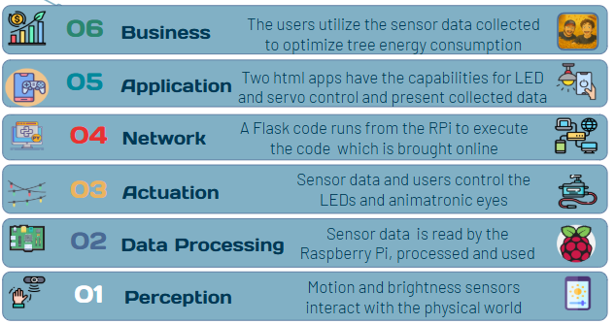Fig. 1: Our 6-layer IoT model
Regarding setup and LED handling, a 2-foot Christmas tree was purchased along with a strip of 50 WS2811 LEDs. Additionally, an independent 5 V power supply was purchased with a DC adapter that wires directly to the LED strip via WAGO connectors. After wire management, the LEDs were positioned uniformly over the tree for the best visual experience. Due to the circuitry of the WS2811 LED strip, the LEDs light up in the order they are wired when they are sequentially programmed. To achieve a broader spectrum of animations (especially those based on geometry), 3D coordinates were collected for each LED. By using a 360-degree protractor and a tape measure, polar coordinates were then converted to Cartesian coordinates for use in generating complex light patterns.
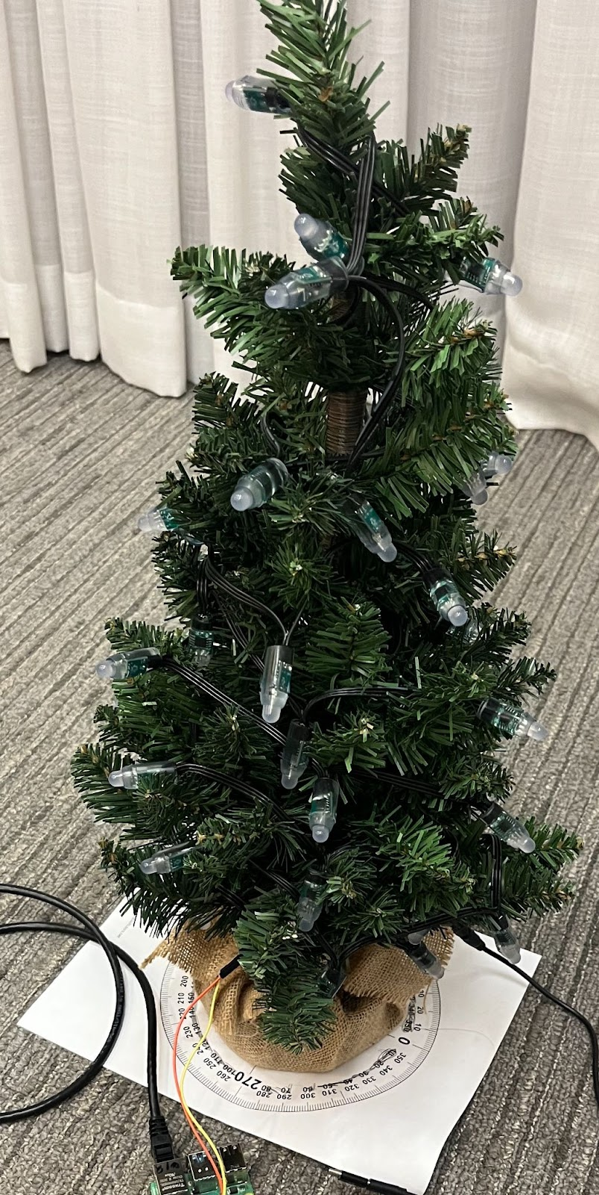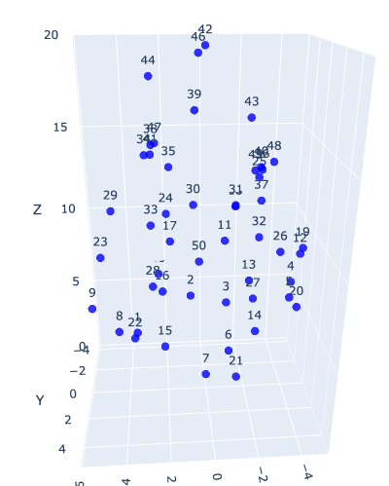
Fig. 2: Christmas tree setup and 3D coordinate scatter plot
On the software side, the rpi_ws281x library provides documentation for programming the LEDs with the important note that this specific strip takes color values in GRB instead of RGB. For animating the lights, several mathematical- and time-based effects were brainstormed, including fireworks, twisters, heartbeats, contagious (proximity-based) effects, and random planes or rotations. Among other sensors, the BH1750 was chosen to detect changes in ambient brightness. Regardless of current LED effects, this sensor will dim or amplify the brightness based on ambient light. The ambient light (and subsequent LED brightness) will be published on the user interface so that peak usage times can be estimated for a continuously lit tree and energy consumption can be decreased where appropriate.
The eyes, located in the Christmas tree, add to its novel design. The motion in the eyes is accomplished by three servo motors controlling each of the individual eyes' left and right motion, and the eyelid that opens and closes the eyes together. The housing was designed, and 3D printed to fit all of the specified 9g servo motors. It was based on an already existing project and modified for the needs of the specific eyes of the tree found at https://www.instructables.com/Animatronic-Eyes-With-Servo-Motors-Arduino/ [3]. The design was also fitted with a clamp in the back to allow for the eyes to be attached to the tree. Wiring them properly to the Raspberry Pi and powering them from the 5V power supply on the Pi allows for movement with programming inputs. The design for the housing of the eyes is provided below.
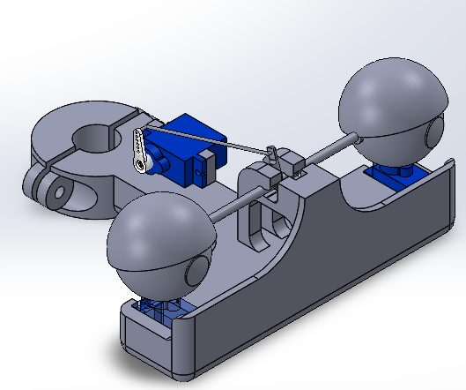
Fig. 3: CAD model of the animatronic eye mount
The programming of the eyes consisted of a Flask app that allows for the eyes to be remotely controlled to move right and left and make the eyelids move up and down. In addition, the code includes an autonomous and dance mode. The autonomous mode enables the eyes to open and close with input from the brightness sensor, closing when the brightness in the room is low and opening when the brightness is high. When motion is detected, the eyes are programmed to cross, alerting the system that motion has been detected and resetting after a set amount of time. Another autonomous mode the user can enable is the dance mode which plays a preprogrammed set of motions in the eyes that makes them seem as if they are dancing. The user can toggle autonomous, dance, and user-controlled modes with the user interface depicted below. Using ngrok, the app can be put online and controlled from a user’s phone. The joystick enables a finely tuned control over the eyes and eyelids allowing for cohesive and near realistic motion. This user interface was brought to fruition using an HTML code that was referenced in the Flask app.
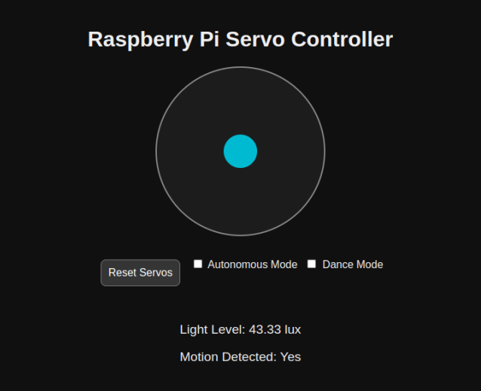
Fig. 4: User interface for the animatronic eye movements
4 Discussion and Results
Several animations and effects were designed and tested using the initialized 3D coordinates. Among several possibilities, linear algebra was regularly applied in the form of orientation or velocity matrices and vectors across the 50 LEDs. Due to the LED number constraints, the most visually effective animations were selected for the final product. A modular user interface was designed for the Raspberry Pi to host over the web as a Flask application, where the user can customize hyperparameters for several effects with proper on/off switches. Upon startup, the sensor immediately provides real-time feedback to increases or decreases in ambient light, publishing the data in a Plotly window accessible at the bottom of the user interface. Overall, there are infinite possibilities for the visual aspect of this product, especially due to its small scale (and thus, smaller computational demand).

While music-LED synchronization was included in the proposal for this product, unfortunately time and resources did not allow for a solution that automates LED effects in relation to musical features due to latency and ineffective frequency processing techniques. However, included in the codebase is a lengthy Python script that applies LED effects corresponding to manually timestamped musical features from Mariah Carey’s “All I Want for Christmas is You” using the audio analysis software Audacity. The full repository including LED effects and audio analysis work can be found at github.com/domsav13/iotxmastree.git.

The servo eyes worked mostly as intended. The user control worked well and allowed for real time control over the system. The dance mode allowed for the preprogrammed inputs to be consistently played when toggled, perfected for when the music-LED synchronized patterns are displayed on the tree. The application of controlling motors remotely on a user’s phone through the Raspberry Pi has many more applications as well in terms of other motorized products or vehicles able to be run remotely over the internet. The system surprisingly had fairly low latency and allowed users to see their inputs quickly, accurately and in real-time.

The main drawback of the system was the autonomous mode and being able to toggle when the system only responded to sensor inputs. While it was clear to see that the system was reading the sensor data thanks to the user interface and the opening and closing of the eyes when the autonomous mode was toggled, it was hard to get the system to update and reset with sensor inputs, leaving much to be desired from that aspect of the device. Allowing the system to read the sensor input passively and only interpreting the data when the mode is toggled is difficult and something to be improved upon in the future.
5 Conclusions and Further Work
In conclusion, the work done for this IoT product represents a promising proof of concept that can be extended to larger scopes, whether in animatronics or large-scale LED operation. Further work includes a more user-friendly interface, or perhaps a separate app that is easy to use and manipulate on mobile devices. Secondly, more work is needed to brainstorm solutions in regard to real-time music synchronization as latency and signal processing remain key hurdles. Incorporating a more diverse set of sensors may potentially help solve these challenges or present other possibilities on a larger scale. Lastly, the presence of motors implies that motion (especially autonomous movement) can be fine-tuned and integrated more effectively with the sensors.
Acknowledgements
We would like to thank Matt Parker, whose 500-LED programmable Christmas tree served as the initial inspiration for this IoT project, and Dr. Kartik Bulusu for providing the Raspberry Pis, sensors, and his support over the course of this final project.
References
[1] Adafruit Circuitpython Neopixel. Adafruit CircuitPython NeoPixel - Adafruit CircuitPython NeoPixel Library 1.0 documentation. (n.d.). https://docs.circuitpython.org/projects/neopixel/en/latest/

[2] Hong, Z. et al. (2016). Research and Implementation of RGB-LED Mixed Light Matching along with Music Playing. International Journal of Grid and Distributed Computing, 9(4), 111-120. http://dx.doi.org/10.14257/ijgdc.2016.9.4.11.

[3] Ikin, C. (2018). Animatronic eyes with servo motors & Arduino. Instructables. https://www.instructables.com/Animatronic-Eyes-With-Servo-Motors-Arduino/

